Greenstop

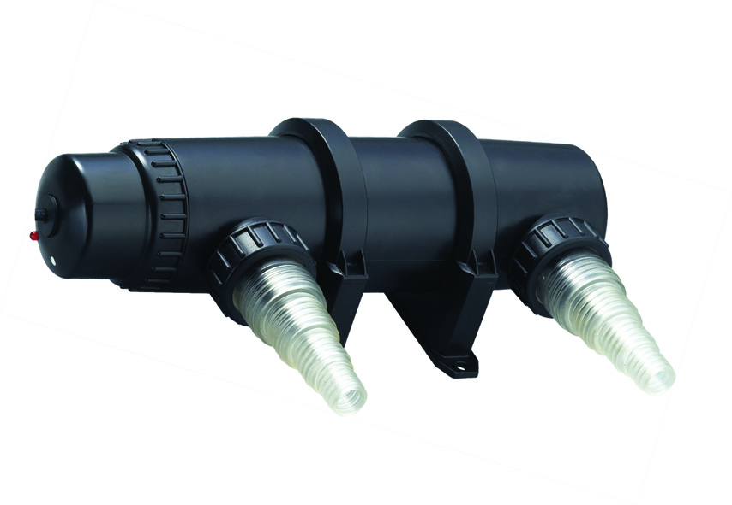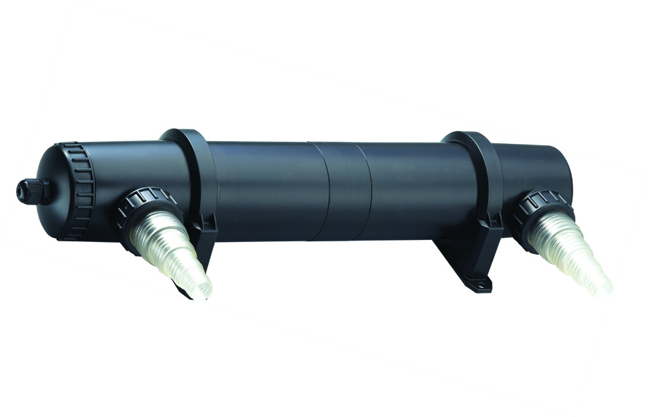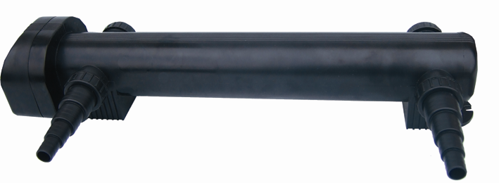
PXUV09000 PXUV23000 PXUV40000

Pond Ultra Violet Clarifier (UVC)

Model | Power Rating | Dimensions  LxDia (mm) | Max.  Flow | Inlet Size  mm | Outlet Size  mm
PXUV09000 | 11W | 310 x 83 | 4500lph | 20/25/32/40 | 20/25/32/40
PXUV15000 | 18W | 310 x 83 | 7500lph | 20/25/32/40 | 20/25/32/40
PXUV23000 | 36W | 503 x 83 | 10000lph | 20/25/32/40 | 20/25/32/40
PXUV40000 | 55W | 630 x 160 | 20000lph | 20/25/32/40 | 20/25/32/40

All UVC supplied with 3-core electrical cable with IP44 rated ballast fitted externally.
All UVC models come complete with a pair of hosetail connections.
All UVC have a rated voltage of 220-240V, 50Hz

Introduction
Congratulations on the purchase of your pondXpert UVC. Once your uvc unit is connected you can look forward to increased water clarity.
Your unit works by exposing your pond to UV light. This causes microscopic algae cells to flocculate (stick together). These larger pieces can then get trapped in filter media as they pass through your pond system.
This unit is designed for outdoor use only. It is weatherproof and should be situated safely pondside. The unit should be sited where it cannot fall into the water or become waterlogged.

NO PART OF THIS UNIT SHOULD EVER BE SUBMERGED IN WATER.

PondXpert products are carefully inspected and tested to ensure both safety and operating performance. However, failure to follow the instructions and warnings in the manual may result in product damage and/or serious injury. Be sure to read and save this manual for future reference.

General safety Instructions
Read and observe all of the instructions before installing, connecting and operating.
Make sure the filter is securely and correctly installed before switching on.
Always disconnect the UV when not in use and when carrying out maintenance.
Always disconnect all equipment in the pond before starting to handle, maintain, repair or install any pond equipment.
The appliance is not intended for use by persons (including children) with reduced physical, sensory or mental capabilities, or lack of experience and knowledge, unless they have been given supervision or instruction concerning use of the appliance by a person responsible for their safety.
Children should be supervised to ensure that they do not play with the appliance.
For safety reasons, servicing or repair of this item should only be carried out by pondXpert.
Never hang or carry the product by the power cord.
Do not operate the uvc with a damaged cord or plug. The supply cord of the appliance cannot be replaced.
Direct exposure to UVC light can damage the eyes and skin. NEVER look directly at the UV when switched on. The translucent inlet will illuminate showing that the UV is working.
If the electrical cord is damaged the product should be scrapped.

Safety and Electrical Connections
The ultra violet clarifier housed within the PondXpert box filter is electrically operated so great care must be taken during installation and operation. The following electrical and safety guidelines must be carefully followed.

Each unit is supplied with a length of 3 core electrical cable which is permanently connected to the ultra violet clarifier unit housed inside the filter.

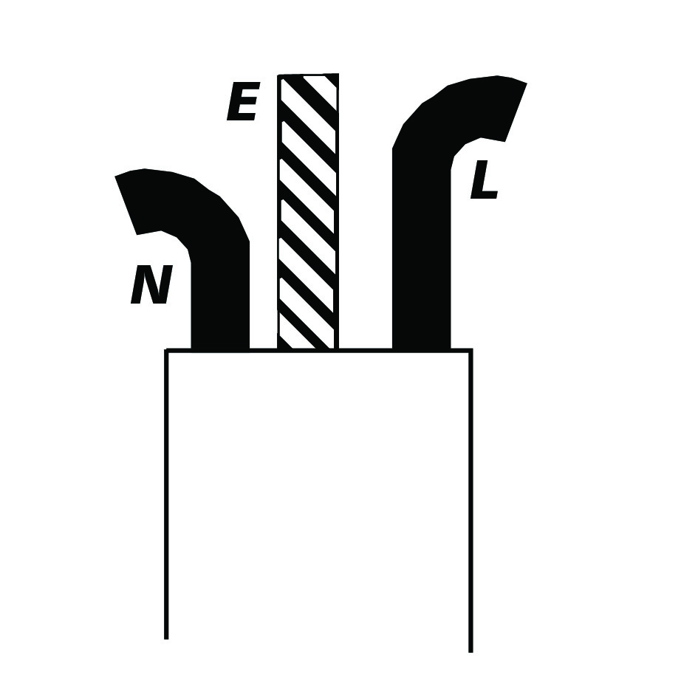
The wires in the mains electrical lead are coloured in accordance with the
following code:
BLUE – Neutral (marked with an “N” in most terminal connections)
BROWN – LIVE (marked with an “L” in most terminal connections)
GREEN/YELLOW – EARTH (marked “E” or in most terminal connections)
1st January 2005 revised Building Regulations for England and Wales
Installing this product in the garden is classified as ‘notifiable’. The Regulations now require you to tell your local authority building control department that you intend to install this product before installation. Your local authority will let you know how you can get your installation approved

The termination to the mains supply should be permanent, inside a dry weatherproof enclosure, through a double pole switched fused spur with a minimum contact gap of 3mm – (disconnected) to BS 3676 – and fitted with a 3 or 5 amp fuse.
Exposed cable runs should be sensibly positioned, and protected if necessary by armoured conduit.
A 10mA or 30mA Residual Current Circuit Breaker (RCD) MUST be fitted to the mains supply.
Permanent installations to the mains supply (hard wiring) must comply with the regulations of the local electricity authority which may stipulate the use of metal or plastic conduit to protect the cable.
If in any doubt about wiring to the mains supply contact a qualified electrician or your local electricity authority.
Protect from frost. In cold winter weather (when fish are inactive and algae growth ceases) the unit may be switched off. It should then be drained of water, removed (if possible) from its installation and stored in a dry, frost-protected area.
The supply cable cannot be replaced. If the cable is damaged, the unit must be discarded.

Directions for use

Installation
Your UVC is electrically operated and designed to be run as part of a pond system. The UVC should be positioned between the flow of water from your pond pump and your filter.
The water must be pumped through the unit and not gravity fed.

Your UV C is fitted with universal hosetails to take ¾”, 1”, 1 ¼” and 1 ½” (20/25/32/40) diameter flexible pond hose. When using the larger diameter hosetails, trim off the smaller sections so as not to impede the water flow. Secure the hose to the hoetails using suitable hose clips. Hose lengths should be kept to a minimum to avoid friction-loss of flow. You should connect the hosetails to the unit using the threaded connectors provided.

The UVC should be positioned before the filter and installed horizontally on a solid surface.

When the UVC is used with a pond filter and pump you should begin to see clear water within 2 weeks (depending on pond conditions and correctly sized equipment).

Periods of operation
Maintain use 24 hrs a day through the fish feeding season (typically early March-October when the water temperature is above 10 degrees C). Algae growth stops during winter months so your unit should be stored indoors over winter. Clean and dry the unit in store it in a dry place.

Maintenance
Your UVC requires minimal maintenance. However, the active UV from the bulb decreases over time and must be changed every 12 months. This is best done during early spring.
Note: The lamp may still look like it is working but you will soon realise it is not effective.

Changing the UV Bulb
Simply unscrew the wired end-cap anti-clockwise. (Press black button on 55w unit)
Remove the UV bulb by gently pulling it out of the electrical connection.
Insert a new tube by pushing gently into the electrical connection.
Re-assemble the end cap by rotating clockwise.

Limited Warranty
This product is guaranteed for a period of 12 months from the date of purchase for material or manufacturing defects. The guarantee covers the substitution of defective parts. However, the guarantee is considered null and void in the case of improper use, improper handling or negligence on the part of the buyer. The UV lamp is not guaranteed. If your pondXpert filter fails please take it back to the retail outlet from where it was purchased. You will be required to take your receipt/proof of purchase with you.
Your appliance contains valuable materials which can be recovered or recycled. Leave it at a local civic waste collection point.
This does not affect your statutory rights.


PondXpert
A3 Bentley Avenue
Billingham
TS23 4BU
UK 01642 370898 www.pondxpert.co.uk

